**Safety**

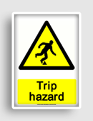For each of the safety signs below, write a statement on how you apply their message in the workshop:

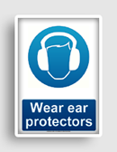

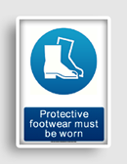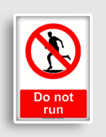

Do Not Run: ***Never run in a workshop!***

Ear Protection:_______________________________________________________

Eye Protection:_______________________________________________________

Think:___________________________________________________________

Protective Footwear:________________________________________________

Trip Hazard:______________________________________________________

 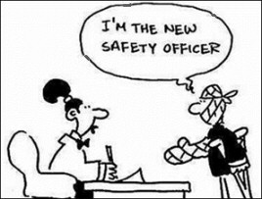

Measuring Exercise

To measure and mark out various woodworking components accurately is the most important skill of all to acquire. The first exercise we will attempt to become proficient at will be to practice working in millimetres and accurately mark out a practice piece of wood, then drill some through holes in it with a Vertical Drill. This will go on to become a fun project where you will learn to use various hand tools and other equipment.

* ***In the table below write a list of all the tools you use in the exercise and what their main purpose is:***

|  |  |  |
| --- | --- | --- |
|  | Tools & Equipment | Main purpose of tool/equipment |
| 1  2  3  4  5  6  7  8  9  10 |  |  |

**Metric Measurement using Millimetres**

* *Using the Metric Rule below, write in the space provided the lengths of the following increments (don’t forget we always measure in mm):*

A:____ B:____ C:____­ D:____ E:____ F:____ G:____

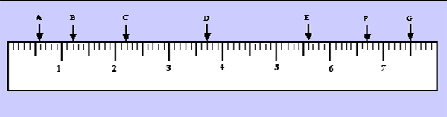

(Note: This rule has been enlarged for practical purposes)

* *Exactly how long is the fish in mm? (Be careful, this one is tricky!)*

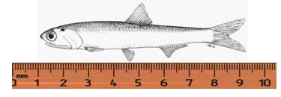 Answer: _____mm

* *Using the rule below, mark in the following measurements.*

A: 30mm B: 63mm C: 103mm

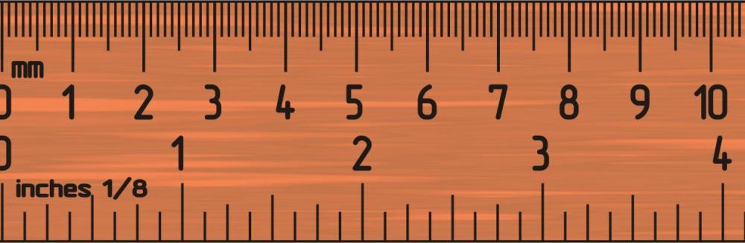

* *Measure the following sizes of your Work Bench:*

Height: ____ Length: _____ Width: ____ Thickness of Bench Top: ____

* *Write the following measurements of the timber provided for your fish exercise:*

Length: ____ Width: ____ Thickness: ____

* *In the space provided, complete a quick sketch of your fish project including the measurements for the position of the through hole and blind hole:*

|  |
| --- |
|  |

Sliding Lidded Box – Project 1

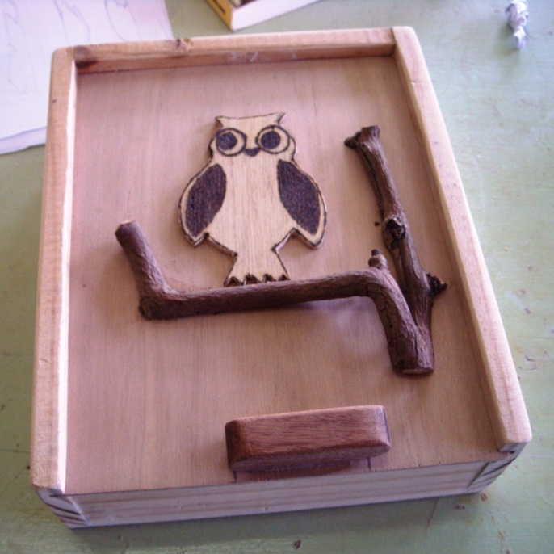

**Design Brief**

Design a Sliding Lidded Box to store items of your choice. You will need to think about what you might like to store in the box. This is important as it will determine the overall measurements of your box. As well as thinking about this you will also be required to design an interesting lid for the box that will incorporate a handle. You may also like to decorate the sides for the box.

You can use multiple layers of plywood to create a 3D effect. Your design may be further enhanced by using the pyrography pen, coloured textas, fine liners or even found objects.

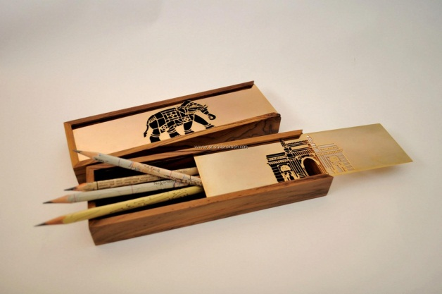

**Constraints:**

* Timber provided is 800 x 60 x 12mm
* Must include a design for the sliding lid
* Must have a handle and the handle must be a part of the design

**Considerations:**

* What will be stored in Box, for example, pencils, money, drumsticks, collectables, jewellery, DS Games, etc.
* Length of your sides and ends of Box
* The design of your lid. Remember it may have many layers for 3D effect
* Using other materials or found objects to enhance your design
* Could make internal compartments and/or dividers
* Shape of the handle. This could be incorporated into the overall design on the lid.
* The design may continue onto the sides and ends of the box.

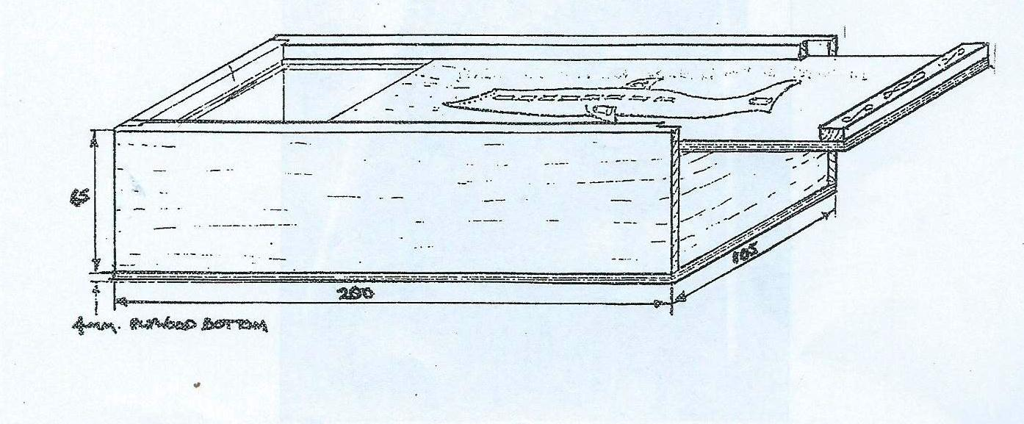

**Visualisations** *Sketch 4 design idea sketches for the box lid in the spaces provided*

|  |  |
| --- | --- |
|  |  |
|  |  |





**Nailing**

**NOTE:**

* **When nailing you must use glue with nails to gain the maximum strength**

**out of your join**

* **Choose the correct nail for the task**
* **Check all sliding cavities are aligned before nailing**
* **25mm nails are used to nail sides and ends together**
* **Ensure frame is square before proceeding to nail on bottom**
* **12mm nails are used to nail plywood bottom to box frame**
* **Nail punch all nails and wood putty holes**

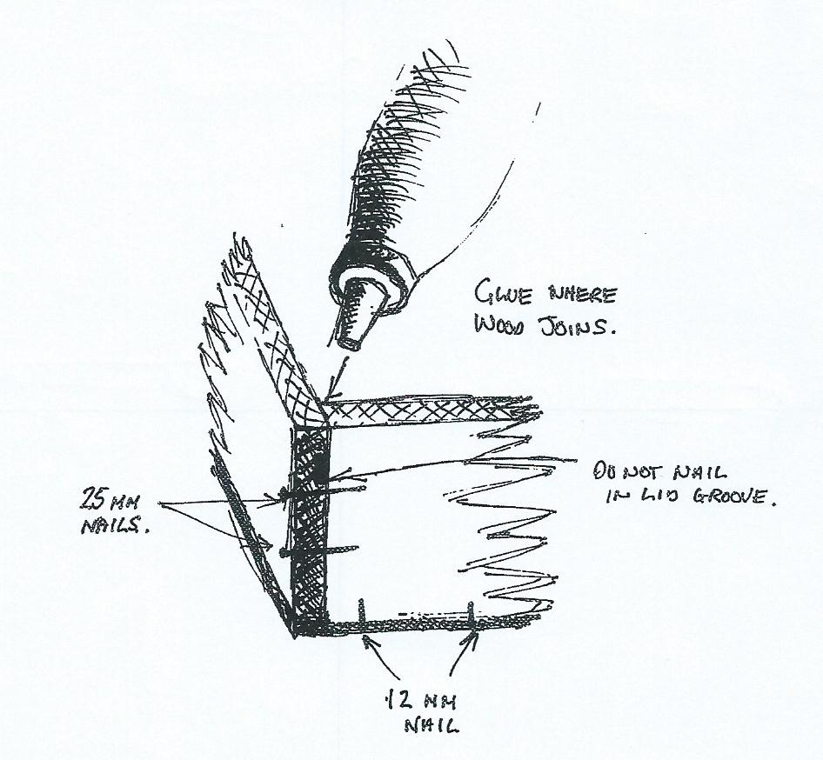

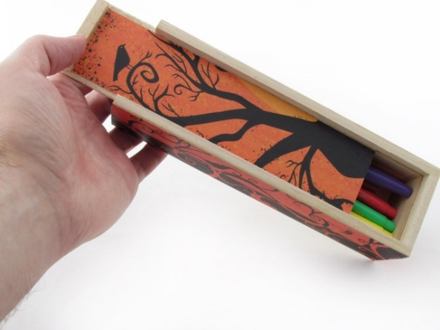

**Production Schedule for Box:** *Fill in the blanks to complete the schedule:*

|  |  |  |  |
| --- | --- | --- | --- |
|  | **Task** | **Tools/Equipment required** | **Time** |
| **1** | **Select timber.** | *Visual inspection for timber defects* | *5min* |
| **2** | **Mark out sides & ends of box *(don’t forget to leave gap for saw blade)*** | *Rule Pencil Template Try Square* | *15min* |
| **3** | **Saw box components to approximate sizes** | *Bench ………………… T………………. Saw* |  |
| **4** | **Cut ends of components to exact size and ensure they are square** | *………………………………………………………………..* |  |
| **5** | **Mark out position of nails onto sides of container** | *Pencil Steel Rule Try S…………..* |  |
| **6** | **Assemble Sides & Ends & check for squareness** | *PVA G………. 25mm Nails H………………..*  *Wet R…….. Try S……………..* |  |
| **7** | **Cut and fit 3mm Plywood Bottom & Sliding Top** | *Sand P……………… Sanding Block*  *6mm Nails H………………… PVA Glue* |  |
| **8** | **Select materials for handle/decal of sliding lid** | *6mm Plywood* |  |
| **9** | **Copy chosen design of handle/decal onto Ply** | *Pencil* |  |
| **10** | **Cut out design** | *S…………… Saw or C……………………… Saw* |  |
| **11** | **Attach design to lid** | *PVA Glue Wet rag Masking tape* |  |
| **12** | **Apply finish** | *Polish Paint Rags Brushes* |  |
| **13** | **Complete Evaluation** | *See below* |  |

**Glossary** - ***Write a short explanation for the following technical words:***

**Visualisation Sketch:_____________________________________________________**

**Isometric:___________________________________________________**

**Orthographic:_________________________________________________**

**Production Plan: ______________________________________________**

**Design Options:_______________________________________________**

**Try Square:_________________________________________________**

**Bullet Head Nail: _____________________________________________**

**Coping Saw:_________________________________________________­_**

**Drill Bit: ___________________________________________________­_**

**G Clamp: ____________________________________________________**

**Bench Hook: _________________________________________________**

**Vertical Drill:_________________________________________________**

**Pyrography: __________________________________________________**

**Through Hole: ________________________________________________**

**Rasp: _______________________________________________________**

**File:________________________________________________________**

**Vice:________________________________________________________**

**Assemble: ___________________________________________________**

**Design Brief: _________________________________________________**

**Constraint: __________________________________________________**

**Tool Identification** *In the area below,* ***sketch*** *6 of the tools listed in the Glossary and* ***Annotate*** *specific parts of each tool ( i.e. show and note the teeth on a saw).*

**Evaluation**

|  |
| --- |
| **Does your product satisfy the design brief? Explain how?**  **What were some of the ‘emergent’ problems you were faced with during the production of your project?**  **How did you solve them?**  **How good is the quality of your work out of 5. /5**  **What things do you think you’re good at? i.e. sawing**  **Where do you think you could improve?**  **How well did you think you used your time? /5**  **What were the main safety issues for you?**  **What strategies did you employ to work safely?**  **What modifications would you incorporate next time you make a product like this?**  **How well did you use your time in class this Semester?** |

**Folio Checklist:** *(Tick off the completed sections of your folio to make sure you are ready for assessment)*

|  |  |  |
| --- | --- | --- |
| 1 | Front Cover that includes name of subject, your name and form and a drawing of something your love or a piece of woodwork you really like |  |
| 2 | Measuring Exercise |  |
| 3 | Design Brief |  |
| 4 | Mind Maps |  |
| 5 | Inspiration Page |  |
| 6 | Visualisation Sketches |  |
| 7 | Design Options x 2 (Isometric with measurements) |  |
| 8 | Orthographic Drawing |  |
| 9 | Production Plan |  |
| 10 | Evaluation Criteria for final product |  |
| 11 | Glossary |  |
| 12 | Tool Identification (annotated sketches of 6 tools used in class) |  |
| 13 | Risk Assessment |  |
| 14 | Evaluation Report (completed after production) |  |